Group Name: Team 8 - Asthma

Assignment Name: Final Paper

Title of eHealth Intervention: eHealth Approaches to Minimize the Effects of Asthma in Children and Young Adults

Target Population: Children ages 7-17

Total Number of Words in Main Narrative: 2,266

Turnitin Similarity Rating: 7%

Date Submitted: April 19, 2024

**Introduction**

Asthma is a prevalent chronic respiratory condition among children aged 7-17, affecting millions worldwide. According to the World Health Organization (WHO), approximately 339 million individuals suffer from asthma globally, and it remains one of the most common chronic diseases in childhood. In the United States alone, nearly 6 million children under the age of 18 are diagnosed with asthma, making it the leading cause of school absenteeism due to chronic illness.

Addressing asthma in children is paramount for several reasons. Firstly, asthma can significantly impair a child's quality of life, affecting their physical activity, sleep, and academic performance. Frequent asthma attacks can disrupt schooling, leading to missed days and decreased productivity. Additionally, poorly managed asthma can result in severe complications, like hospitalizations. Moreover, asthma imposes a substantial economic burden on families due to medical expenses.

The target population for asthma management primarily encompasses children aged 7-17. This age group is particularly vulnerable to asthma exacerbations due to factors such as exposure to allergens, respiratory infections, and environmental triggers. Also, children in this age range may face challenges in adhering to treatment regimens and recognizing early symptoms, requiring specialized interventions and support.

Several barriers hinder asthma patients, especially children, from receiving proper care. Limited access to healthcare services, including specialist consultations and medications, can exacerbate asthma symptoms and lead to poor outcomes. Socioeconomic factors such as poverty, inadequate housing, and exposure to environmental pollutants contribute to the burden of asthma in vulnerable populations. Furthermore, stigma and misconceptions surrounding asthma may result in delays in seeking medical attention and inadequate support from peers and educators.

In addition, environmental factors such as air pollution, tobacco smoke, and allergens can worsen asthma symptoms and trigger exacerbations. Climate change poses additional challenges by increasing the prevalence of allergens and extreme weather events, which may trigger respiratory conditions like asthma. Addressing these environmental determinants of health is crucial for mitigating the impact of asthma on children and improving their long-term outcomes.

To conclude, asthma remains a significant health concern among children aged 7-17, with several implications for their well-being and quality of life. Tackling asthma requires a comprehensive approach encompassing education, access to healthcare, and environmental policies. By addressing the information and support needs of children with asthma, overcoming barriers to care, and addressing environmental determinants, we can enhance the management of asthma and improve outcomes for this vulnerable population. Therefore, our team's intervention aims to help children with asthma through education on triggers and symptom management. Our intervention app will offer a range of components tailored to this goal, including a weather tracker to alert users to potential triggers like pollen, a messaging area for direct communication with healthcare providers, an asthma symptom tracker for monitoring health, and medication reminders. Additionally, a fun, educational game within the app will engage children and reinforce essential information about asthma in an interactive way. By providing comprehensive resources and support, our intervention seeks to improve asthma management and enhance the well-being of children living with this respiratory condition.

**Review of Literature**

With the continual progression and increased amount of people with asthma, various eHealth technologies have also begun to sprout and increase as well to support patient education and self-management in asthma. Some technologies that have revolutionized asthma management are mobile apps for asthma management, smart inhalers, and online tracking tools. Mobile apps like Asthma Buddy and My Asthma App let patients learn more and understand their asthma through the educational resources on asthma management provided through the app itself, and it will give periodic medical reminders that help the user stay on track with their asthma medicine. Having a dedicated app for asthma will increase the accessibility for everyone and increase the efficacy by having apps with personal customization. Smart inhalers help patients with their self-management by sending reminders about when to take medication, the dosage, and potential patterns, and can alert the patient about any potential asthma triggers in the environment. Inhalers will always be carried by the patient and having additional technical support will only improve its efficacy by helping the patients understand their medication and its impact on their asthma management. Online tracking tools vary from asthma diaries, asthma websites, and even asthma apps themselves. By having an online tracking tool patients will be able to better understand asthma and their self-management needs by tracking their symptoms over time and allowing patterns to be identified, thus allowing the patients themselves to better understand themselves and control their situation.

With multiple variations of eHealth technologies for asthma, some aspects lead to poorly designed technology that is not as successful. Having poorly designed usability issues can hinder patients from navigating apps, having premium features limits accessibility and provides a barrier to some with financial restrictions, and finally being too technologically dependent. Instead what works are having an intuitive design, real-time feedback, personal customization, data analysis, and being affordable.

We learned that it is important to have a simple but efficient eHealth intervention to not clutter it from its main purpose and to make it more accessible so everyone can use it. Some ideas we got for designing our technology component were to make an app and include a tracking tool, daily reminders, a diary, a game aspect, and an environment tracking aspect.

**Description of the Technology Feature/Sub-component**

The proposed mobile app technology aims to provide a comprehensive solution for asthma patients, particularly those between the ages of 7 and 17, to effectively manage their condition and improve their overall well-being. The app will consist of several sub-components, each designed to address specific self-management needs of asthma patients. One sub-component is an asthma symptom tracker that allows users to log and monitor their symptoms, including coughing, wheezing, shortness of breath, and chest tightness. Users can record the severity and frequency of their symptoms, as well as any potential triggers they may have encountered. The app will provide visual representations of symptom patterns over time, enabling users to easily identify trends and potential triggers. Another key feature is a healthcare provider communication line that facilitates seamless communication between asthma patients and their healthcare providers. Users can securely send messages, and contact their providers in case of emergency. Healthcare providers can respond to inquiries, provide personalized advice, and adjust treatment plans as needed, ensuring timely and effective care. The app will also include educational resources on asthma management, such as videos, articles, and interactive modules. These resources will cover topics like understanding asthma triggers, proper inhaler techniques, managing asthma during physical activity, and creating an asthma action plan. The educational content will be tailored to different age groups and learning styles, ensuring accessibility and engagement for all users. Additionally, users can request refills or new prescriptions for their asthma medications directly through the app. The app will integrate with local pharmacies or healthcare providers to streamline the prescription process. Users can track their medication usage, set reminders for taking their medications, and receive alerts when refills are needed. Furthermore, the app will feature tracking tools that allow users to monitor various factors that may influence their asthma management, such as physical activity levels, environmental conditions (e.g., air quality, pollen counts), and medication adherence. The app will provide personalized insights and recommendations based on the tracked data, empowering users to make informed decisions about their self-management strategies.

The main users of this mobile app technology will be asthma patients between the ages of 7 and 17, as well as their caregivers or parents. The app is designed to support several educational and behavioral objectives, including reducing the need for doctor visits, increasing physical activity levels, improving communication between patients and healthcare providers, reducing asthma flare-ups and minimizing symptoms, making asthma medication more accessible, and educating patients and caregivers on asthma management, triggers, and proper inhaler technique.

To illustrate how the app will benefit users, imagine the following scenario: Sarah, a 12-year-old asthma patient, and her parents have recently downloaded the asthma self-management app. After creating their profiles, Sarah logs her asthma symptoms daily, noting any potential triggers she encountered. The app's visual representations help Sarah and her parents identify that her symptoms tend to worsen during high pollen count days. Through the app's educational resources, Sarah learns about managing asthma during physical activity and proper inhaler technique. She can now participate in her favorite sports with confidence, knowing how to prevent and manage potential asthma flare-ups. When Sarah needs a refill for her inhaler, her parents can request it directly through the app, which seamlessly integrates with their local pharmacy. They also receive reminders to ensure Sarah takes her medication as prescribed. If Sarah experiences any concerning symptoms or has questions about her asthma management, her parents can easily communicate with her healthcare provider through the app's secure messaging system. The provider can review Sarah's symptom logs and provide personalized advice or adjust her treatment plan.

The app's design is based on user-centered design principles and evidence-based practices in asthma self-management. Integrating various features into a single platform, the app aims to empower asthma patients and their caregivers with the knowledge, tools, and support necessary for effective self-management. This comprehensive approach is expected to improve asthma control, reduce the burden on healthcare systems, and enhance the overall quality of life for asthma patients.

**Paper Prototypes**

The medication reminder component is meant to inform users of their daily medication intake. This screen of the app includes a calendar that allows you to navigate when and what medicine should be taken each day. The reminder screen sends a notification to the home screen of the user’s phones to let them know when it is time to take that specific medication. 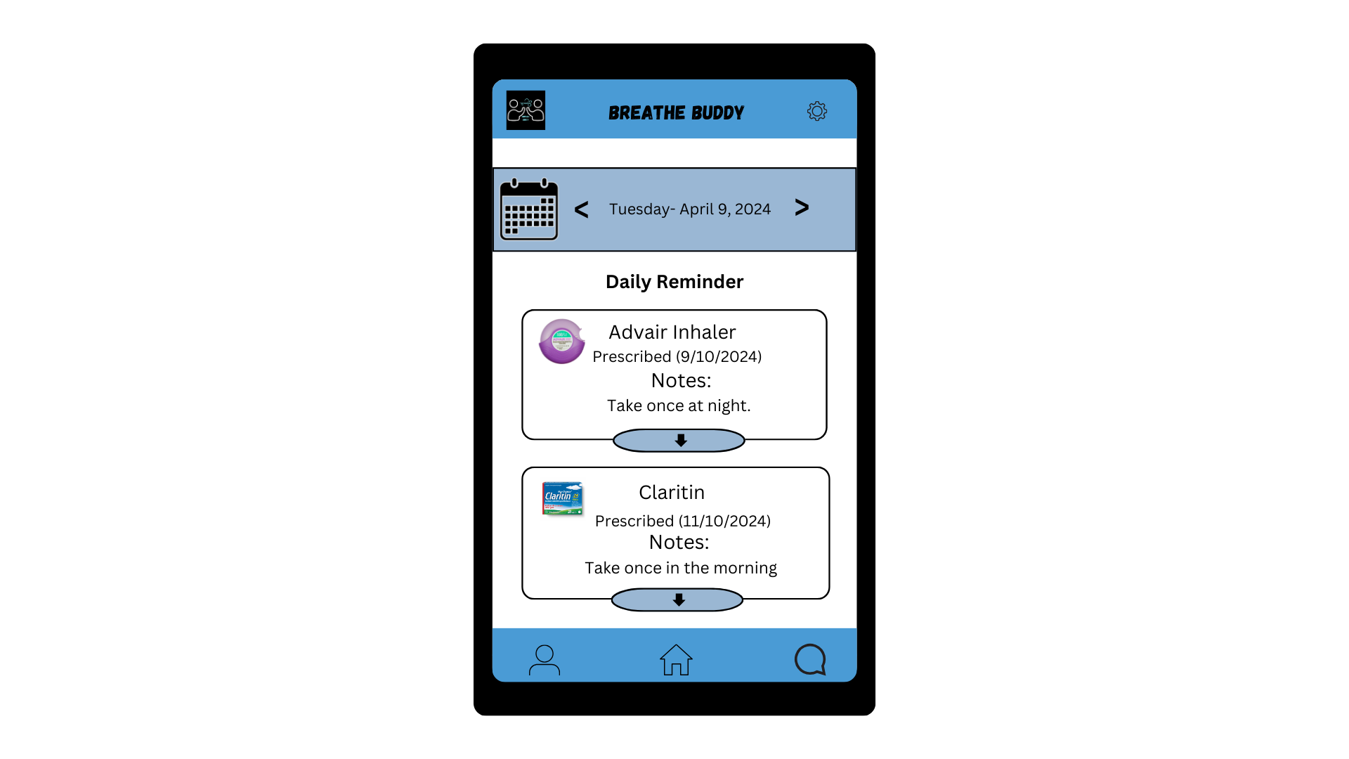

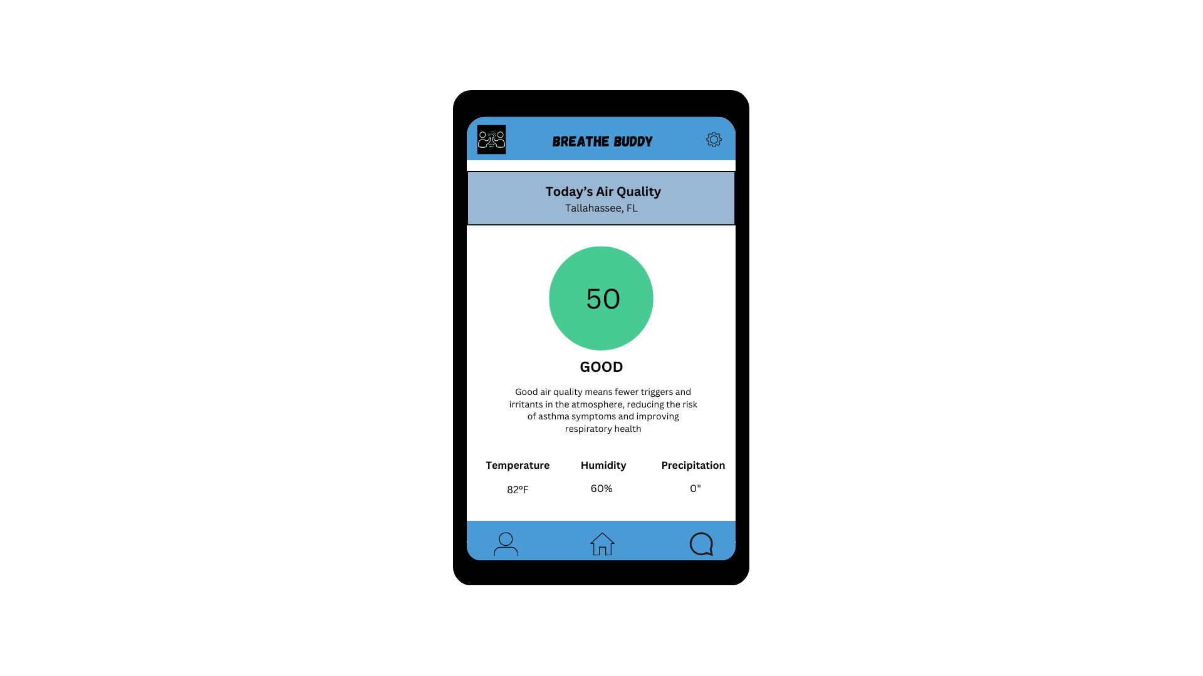

The purpose of this prototype is to share the air quality of the user’s area. One feature of this screen is that it changes daily according to the weather. It also teaches the user about different levels of air quality, like in the example above where it explains what good air quality means. This section of the app also shares the temperature, humidity, and precipitation with the user.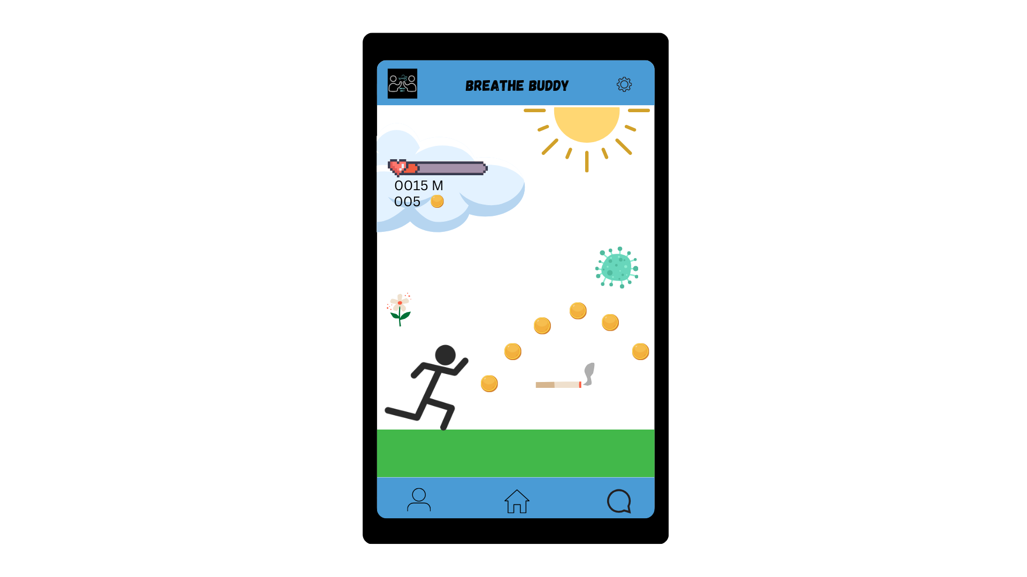

The Breathe Buddy game takes the user on an adventure with a character named Breathe Buddy. In this game, the player is meant to dodge triggers including smoking, pollen, and illnesses that could negatively affect their asthma. The purpose of this game is to educate users on what triggers to avoid. Some features of this game include a health bar that goes down if the user fails to dodge any of the triggers and also coins that the player can collect.

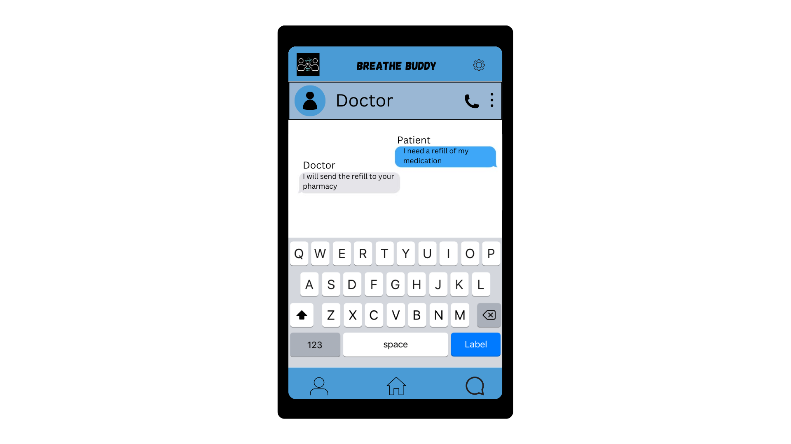

The prototype above displays a screen that allows users to directly message or call their doctors. Although this system is not recommended for emergencies, it is a great way for users to connect with their doctor when in need of medical advice or help.

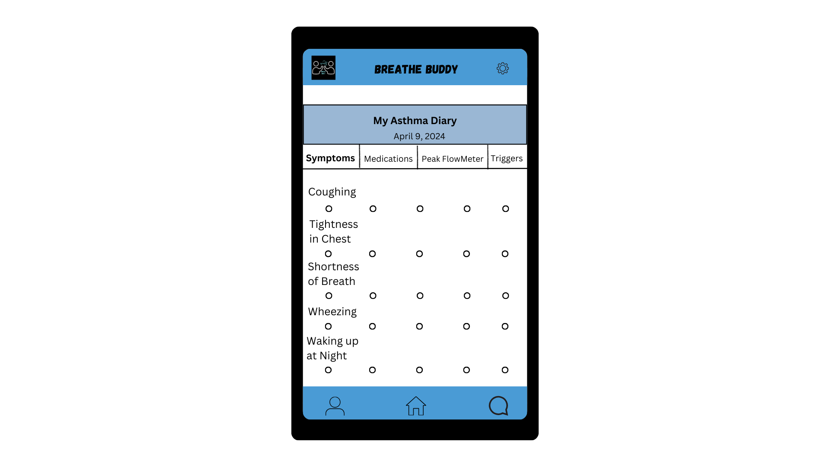

This prototype is the Asthma Diary and is meant to give users a space to log their symptoms, medications, peak flow meter, and triggers. The screen above shows the symptom log screen which allows users to mark which symptoms have affected them on that particular day. This feature contains five marks that the user can use to record how the symptoms affected them from low to high.

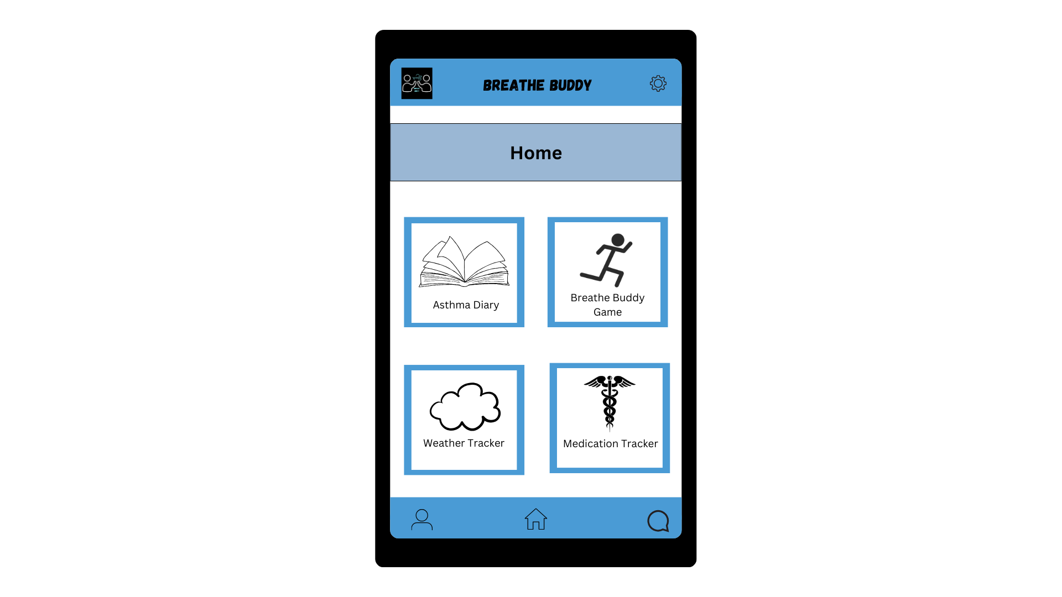

This is the home screen of the app that allows users to navigate to each feature. The four squares include Asthma Diary, Breathe Buddy Game, Weather Tracker, and Medication Tracker. On the bottom panel of the screen is where the user can reach their profile, home screen, and messages. The message and profile buttons are located on the bottom panel for the user to have immediate access.

**Marketing & Engagement**

The need for a successful marketing strategy is an important part of improving the level of engagement that users will have with a certain brand or product (Snyder, 2023). For a product like Breathe Buddy, part of a successful approach to marketing will consist of establishing an internet presence early. The target user group will be patients ages 7 - 17, as well as their caregivers. This is a very large group to account for, so the need for a digital presence is crucial to make Breathe Buddy more attractive to the modern patient. This will be established through both the mobile application, as well as the main Breathe Buddy website by implementing elements of e-marketing via social media platforms. By having the website optimized with relevant keywords, backlinks to social media sites, and appropriate meta tags we believe that we will be able to reach an increased number of potential users (Cushman, 2018). Patients seeking ways to better manage and avoid their asthma symptoms will also benefit from the more modern technological aspects of the Breathe Buddy involving its virtual care features. Telemedicine can allow for improved access for patients while helping tailor treatment to their specific triggers and symptoms.

In terms of facilitating and maintaining engagement with Breathe Buddy’s target audience, our user-centric design will help increase the desirability of our approach to asthma management. An example of such an approach is the integration of our interactive surveys and provider profiles, which gives users a more comprehensive view of how their specific asthma needs will be met. Subsequently, a greater emphasis on the individual patient will result in a more long-lasting connection between Breathe Buddy and the user. Another proven strategy that will help to ensure the long-term use and effectiveness of Breathe Buddy is collaboration with other asthma companies and healthcare providers (Sowden et al., 2022). These partnerships will not only help doctors expand their overall accessibility to patients but can also serve as a way to help reduce many unnecessary hospital readmissions for situations like follow-up visits.

**References**

Association, A. L. (n.d.). *Asthma Treatment*. Retrieved February 9, 2024, from<https://www.lung.org/lung-health-diseases/lung-disease-lookup/asthma/treatment>

*Asthma*. (n.d.). Retrieved April 19, 2024, from<https://www.who.int/news-room/fact-sheets/detail/asthma>

CDC. (2023, June 8). *Learn how to take control of asthma*. Centers for Disease Control and Prevention.<https://www.cdc.gov/asthma/faqs.htm>

Cushman, M. (2018). Search engine optimization: What is it and why should we care? *Research and Practice in Thrombosis and Haemostasis*, *2*(2), 180–181. <https://doi.org/10.1002/rth2.12098>

FastStats. (2023, December 26).<https://www.cdc.gov/nchs/fastats/asthma.htm>

Freitas, P. D., Xavier, R. F., Passos, N. F. P., Carvalho-Pinto, R. M., Cukier, A., Martins, M. A., Cavalheri, V., Hill, K., Stelmach, R., & Carvalho, C. R. F. (2019). Effects of a behaviour change intervention aimed at increasing physical activity on clinical control of adults with asthma: Study protocol for a randomised controlled trial. *BMC Sports Science, Medicine and Rehabilitation*, *11*(1), 16.<https://doi.org/10.1186/s13102-019-0128-6>

Li, X., Zhang, Y., Zhang, R., Chen, F., Shao, L., & Zhang, L. (2022). Association Between E-Cigarettes and Asthma in Adolescents: A Systematic Review and Meta-Analysis. *American Journal of Preventive Medicine*, *62*(6), 953–960.<https://doi.org/10.1016/j.amepre.2022.01.015>

Lista-Paz, A., Bouza Cousillas, L., Jácome, C., Fregonezi, G., Labata-Lezaun, N., Llurda-Almuzara, L., & Pérez-Bellmunt, A. (2023). Effect of respiratory muscle training in asthma: A systematic review and meta-analysis. *Annals of Physical and Rehabilitation Medicine*, *66*(3), 101691.<https://doi.org/10.1016/j.rehab.2022.101691>

McLoughlin, R. F., Clark, V. L., Urroz, P. D., Gibson, P. G., & McDonald, V. M. (2022). Increasing physical activity in severe asthma: A systematic review and meta-analysis. *The European Respiratory Journal*, *60*(6).<https://doi.org/10.1183/13993003.00546-2022>

Sanz-Santiago, V., Diez-Vega, I., Santana-Sosa, E., Lopez Nuevo, C., Iturriaga Ramirez, T., Vendrusculo, F. M., Donadio, M. V. F., Villa Asensi, J. R., & Pérez-Ruiz, M. (2020). Effect of a combined exercise program on physical fitness, lung function, and quality of life in patients with controlled asthma and exercise symptoms: A randomized controlled trial. *Pediatric Pulmonology*, *55*(7), 1608–1616.<https://doi.org/10.1002/ppul.24798>

Snyder, K. (2023, November 6). What is marketing? Definition, Strategies & best Practices. *Forbes Advisor*. <https://www.forbes.com/advisor/business/what-is-marketing/>

Sowden, G., Shoemaker, A., Batliner, M., & Duncan, M. (2022, July 12). *Psychiatric e-Consults: a guide for the referring physician*. Brand. <https://www.aafp.org/pubs/fpm/issues/2022/0700/psychiatric-econsults.html>

Appendix - Attach the conceptual Framework/Map

